During acceleration enrichment additional injector pulses are inserted ‘asynchronously’

Case 1:

Idle switch on, at 3000rpm (AWG = 100Hz) and approx. 10% calculated load:

ch1 is the CAS  
ch2 is the injector driver  
ch3 is the TPS

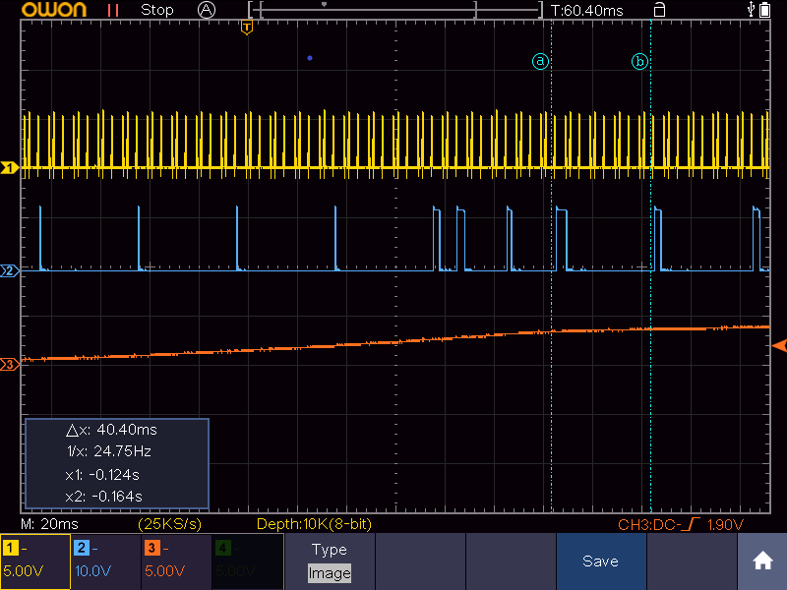

Injection is initially at one pulse every 720 degrees, synchronised to the 6 BTDC CAS input.

At the TPS trigger point an additional pulse is injected 90 degrees later at the following 6 BTDC input (2.62ms).

A second additional pulse (3.1ms) is injected after a further 180 degrees, again at 6 BTDC.

A third additional pulse (1.42ms) is injected after a further 180 degrees.

A fourth pulse (4ms) is injected after 180 degrees

Injection reverts to every 720 degrees at 2.58ms, however the injector pulse has shifted and is synced with a different cylinder.

Case 2: Idle switch on at 3000rpm (AWG = 100Hz) and approx. 65% calculated load:

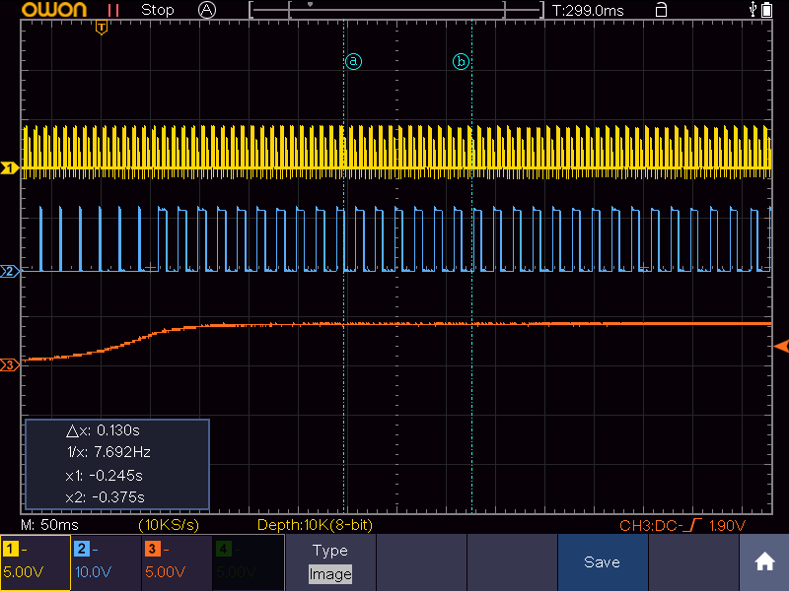

Under a high load injection takes place every 180 degrees, no additional pulses are inserted and any change in injector PW is small.